**Lab Report # 2**



**Course Code:**

EE231

**Submitted By:**

Haider Ali

**Registration No:**

FA21-BEE-053

**Submitted To:**

Dr. Ali Arshad

**Lab # 2 Current-Voltage characteristics of a PN junction diode and Diode Logic Gates**

**OBJECTIVES**

• To examine the forward biased characteristics of a silicon diode

• To examine the reverse biased characteristics of a silicon diode and study its Application as Diode logic Gate

**EQUIPMENT AND MATERIALS**

• 0-15 V dc power supply

• 1 K ohm resistor

• Breadboard

• 1N914 Silicon diode

• Digital Multi-meter

**In-Lab**

**Section I (FUNCTIONAL EXPERIMENT)**

|  |  |  |  |
| --- | --- | --- | --- |
| **INPUT VOLTAGE** | **Diode voltage** | **Voltage across 1K ohm resistor** | **Diode forward current** |
| 0.1V | 131.8mV | 0.1mV | 0mA |
| 0.2V | 304.9mV | 1.1mV | 0.001mA |
| 0.3V | 338.5mV | 3mV | 0.002mA |
| 0.4V | 0.501V | 195.1mV | 0.181mA |
| 0.5V | 0.477V | 110.1mV | 0.105mA |
| 0.6V | 0.506V | 212.1mV | 0.157mA |
| 0.7V | 0.510V | 239.3mV | 0.239mA |
| 0.8V | 0.524V | 319.9mV | 0.291mA |
| 0.9V | 0.539V | 0.434V | 0.399mA |
| 1V | 0.547V | 0.509V | 0.48mA |
| 2V | 0.598V | 1.431V | 2.37mA |
| 3V | 0.623V | 2.406V | 3.36mA |
| 4V | 0.641V | 3.427V | 4.32mA |
| 5V | 0.653V | 4.37V | 5.29mA |
| 6V | 0.663V | 5.44V | 6.31mA |
| 7V | 0.671V | 6.40V | 7.26mA |
| 8V | 0.677V | 7.37V | 8.25mA |
| 9V | 0.688V | 8.43V | 9.26mA |

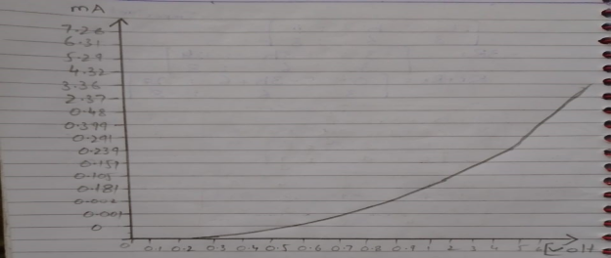

**Section II** (Logic Gates Implementation Using Diodes)

**(Part A)**

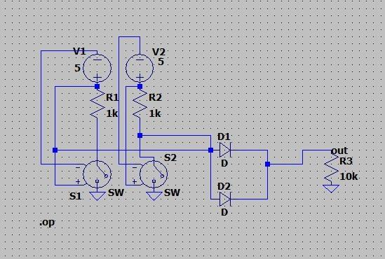

|  |  |  |  |  |  |
| --- | --- | --- | --- | --- | --- |
| **So** | **S1** | **State of DA** | **State of DB** | **VY with LED** | **VY without LED** |
| 0 | 0 | 1 | 1 | 2.3mV | 0.1V |
| 0 | 1 | 1 | 0 | 2.57V | 4.1V |
| 1 | 0 | 0 | 1 | 2.5V | 4.12V |
| 1 | 1 | 0 | 0 | 2.7V | 4.37V |

Logic truth table for OR Gate is:

|  |  |  |
| --- | --- | --- |
| **A** | **B** | **Y** |
| 0 | 0 | 0 |
| 0 | 1 | 1 |
| 1 | 0 | 1 |
| 1 | 1 | 1 |

**(Part B)**

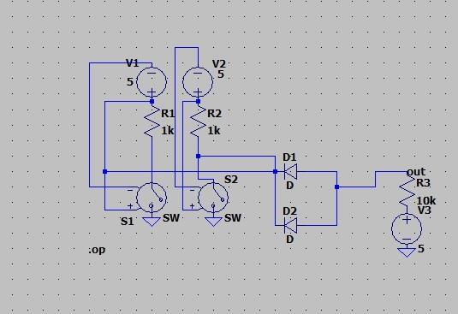

|  |  |  |  |  |  |
| --- | --- | --- | --- | --- | --- |
| **So** | **S1** | **State of DA** | **State of DB** | **VY with LED** | **VY without LED** |
| 0 | 0 | 0 | 0 | 4.6V | 5.04V |
| 0 | 1 | 0 | 1 | 4.55V | 5.06V |
| 1 | 0 | 1 | 0 | 4.55V | 5.06V |
| 1 | 1 | 1 | 1 | 0V | 5.09V |

Logic truth table for AND Gate is:

|  |  |  |
| --- | --- | --- |
| **A** | **B** | **Y** |
| 0 | 0 | 0 |
| 0 | 1 | 0 |
| 1 | 0 | 0 |
| 1 | 1 | 1 |

**Section 3 -Design Problem**

**Design a series diode configuration having two Voltage sources 10V and 5V and two resistors 4.7k and 2.2k. Simulate it on LTspice**.

**Post-Lab Discussion**

• Comment on the output of the Figure 3.5.

In this figure 3.5 we have two switches and two diodes. When we open both switches then the voltage start passing through the diodes and diodes will forward bias. Due to this, LED glows. When we close any one switch and open other doesn’t matter, our one diode will pass current, and LED also glows in this case. But if we close both switches, all current start moving towards ground and no current will pass through diodes and LED do not glow. Here we have OR logic operation.

• Comment on the output of the Figure 3.6

Same case is here, we have three voltage sources, two diodes and two switches. When we open both switches, no current will pass through the diodes because of their reverse bias and LED will not glow. When we close any one switch then the LED glows because by closing one switch, diode connected to it will forward bias, passes current. And closing both also glows LED because of its both diodes will forward bias in this case.

**Critical Analysis:**

We have learn how to use diodes to create various binary gates, mainly and & or gates. We have also learn how to verify the diode V/I graph by creating the graph itself and then verifying on the instruments as well.I constructed AND an OR gate using diode and resistor. In task 1 I took different input voltage and measured diode voltage and voltage across resistor. Afterwards I simulated my circuit on LTspice.